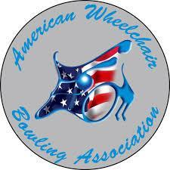 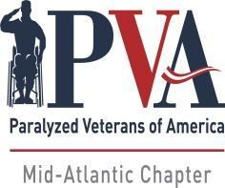

**9th ANNUAL PVA MID-ATLANTIC INVITATIONAL**

***(Sanctioned by AWBA)***

**September 19-21, 2025**

**BOWLING CENTER LOCATION:**

AWBA#: ________ USBC#: ________

Bowl America - Short Pump

4400 Pouncey Tract Rd

Glen Allen, VA 23060

**ALL REGISTRATIONS & PAYMENTS MADE DIRECTLY TO PVA MID-ATLANTIC**

Singles Entry Fee: $150.00

Doubles: $ 30.00

Up & Down: $ 30.00

9th Year Donation: $ ______

Total: $ ______

**Mail Entry Form & Fees To:**

PVA Mid-Atlantic

11620 Busy St.

No. Chesterfield, VA 23236

Or: via PayPal: https://www.pvamidatlantic.org/donate/

**Please Print:**

Name:

Address:

City: State: Zip:

Phone#: Email:

**Check Division Entering:** SCRATCH: HANDICAP:

Doubles: Partner: Handicap: Please Assign:

Up & Down: Partner: Handicap: Please Assign:

Partner: Handicap: Please Assign:

Partner: Handicap: Please Assign:

**Average Verification: Failure to provide required verification will result in any prize money and/or other awards**

**being withheld until such verification is submitted.**

**Those without qualified averages must bowl in the scratch division. The AWBA adjusted tournament average designee will provide adjusted tournament average information. In all cases where the adjusted tournament average is USBC book average, the adjusted tournament average will be the entrant's entering average. All participants must present valid AWBA and USBC membership cards. AWBA and USBC membership fees will be accepted for new members, which is required to participate in the event. For new bowlers, a league scoresheet will be accepted to establish an average (a minimum of 12 games).**

Signature

Please check all that apply Power Chair **___** Manual**___** Para **___** Quad  **___** Stick **____**

Are You a PVA Member? ____Yes ____No Chapter:_____________________

Shirt Size: M L XL 2XL 3XL