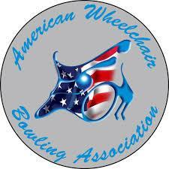 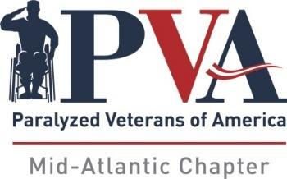

**9th ANNUAL PVA MID-ATLANTIC INVITATIONAL**

***(Sanctioned by AWBA)***

**Bowl America – Short Pump, VA**

**September 19-21, 2025**

**REGISTRATION DEADLINE - AUGUST 30, 2025**

On behalf of the PVA Mid-Atlantic Chapter, please accept our invitation to join us for the 9th Annual PVA Mid-Atlantic Invitational – *Sanctioned by AWBA*. Every year, our tournament committee takes great pride in providing our bowlers, their families and caregivers with a first-class experience – and this year we hope to showcase our best event yet!

We hope that you will consider our official tournament hotel for your accommodations. Other options are provided – all of which have many restaurants and popular shopping areas nearby. Please be aware that the tournament committee will not be handling transportation to or from the hotels or bowling center. It will be helpful if those of you who are driving would consider ride-sharing with your fellow participants.

As tournament director, I hope that each of you will consider joining us this year. Even better, spread the word, and share the fun and excitement of our tournament with other bowlers!

Yours in fellowship,

Jimmy May

Tournament Director

PVA Mid-Atlantic Chapter

11620 Busy St

No. Chesterfield, VA 23236

804-378-0017

Jimmy May

2641 Sandhurst Ln

Midlothian VA, 23113

Home 804-794-7447

Cell 804-240-9019

Bowl America - Short Pump

4400 Pouncey Tract Rd

Glen Allen, VA 23060

804-360-8222

**OFFICIAL TOURNAMENT HOTEL:**

**Embassy Suites by Hilton Contact:**

**2925 Emerywood Parkway Steven Rios – Sales Manager**

**Richmond, VA 23294 $159 / Night**

**(804) 672-8585 Includes 2-room suites, made-to-order breakfasts & complimentary cocktail hours**

**(Make your reservations early - ADA suites are limited)**

OTHER HOTEL OPTIONS:

Hyatt Place Innsbrook Hampton Inn & Suites Hilton Garden Inn Holiday Inn Express Fairfield Inn & Suites

4100 Cox Rd. 12341 W. Broad St. 4050 Cox Rd. 9933 Mayland Dr. 9937 Mayland Dr.

Glen Allen, VA Richmond, VA Glen Allen, VA Richmond, VA Richmond, VA

(804) 747-9644 (804) 773-7111 (804) 521-2900 (804) 934-9300 (804) 799-1200

 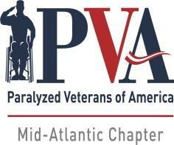

**9th ANNUAL PVA MID-ATLANTIC INVITATIONAL**

***(Sanctioned by AWBA)***

**September 19-21, 2025**

**BOWLING CENTER LOCATION:**

AWBA#: ________ USBC#: ________

Bowl America - Short Pump

4400 Pouncey Tract Rd

Glen Allen, VA 23060

**ALL REGISTRATIONS & PAYMENTS MADE DIRECTLY TO PVA MID-ATLANTIC**

Singles Entry Fee: $150.00

Doubles: $ 30.00

Up & Down: $ 30.00

9th Year Donation: $ ______

Total: $ ______

**Mail Entry Form & Fees To:**

PVA Mid-Atlantic

11620 Busy St.

No. Chesterfield, VA 23236

Or: via PayPal: https://www.pvamidatlantic.org/donate/

**Please Print:**

Name:

Address:

City: State: Zip:

Phone#: Email:

**Check Division Entering:** SCRATCH: HANDICAP:

Doubles: Partner: Handicap: Please Assign:

Up & Down: Partner: Handicap: Please Assign:

Partner: Handicap: Please Assign:

Partner: Handicap: Please Assign:

**Average Verification: Failure to provide required verification will result in any prize money and/or other awards**

**being withheld until such verification is submitted.**

**Those without qualified averages must bowl in the scratch division. The AWBA adjusted tournament average designee will provide adjusted tournament average information. In all cases where the adjusted tournament average is USBC book average, the adjusted tournament average will be the entrant's entering average. All participants must present valid AWBA and USBC membership cards. AWBA and USBC membership fees will be accepted for new members, which is required to participate in the event. For new bowlers, a league scoresheet will be accepted to establish an average (a minimum of 12 games).**

Signature

Please check all that apply Power Chair **___** Manual**___** Para **___** Quad  **___** Stick **____**

Are You a PVA Member? ____Yes ____No Chapter:_____________________

Shirt Size: M L XL 2XL 3XL

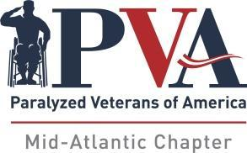

**9th ANNUAL PVA MID-ATLANTIC INVITATIONAL**

***(Sanctioned by AWBA)***

**SINGLES PRIZE FUND**

**Scratch Division A Division B Division**

1st $1400 1st $1400 1st $1400

2nd 900 2nd 900 2nd 900

3rd 600 3rd 600 3rd 600

4th 400 4th 400 4th 400

5th 300 5th 300 5th 300

**Total $3600** **Total $3600** **Total $3600**

**Scratch Division Scratch Division A & B Divisions A & B Divisions TOTAL**

HSG - $75 HHS - $75 HHG - $75 x 2 HHS - $75 x 2 **$ 450**

**DOUBLES PRIZE FUND**

1st $450

2nd $250

3rd $150

4th $100

**Total $850**

**UP & DOWN PRIZE FUND**

1st $450

2nd $300

3rd $225

**Total $975**

**TOTAL TOURNAMENT PRIZE FUND - $13,175**

The PVA Mid-Atlantic Chapter reserves the right to increase or decrease the prize fund

based on overall registrations and participants

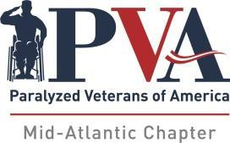

**9th Annual PVA Mid-Atlantic Invitational**

***(Sanctioned by AWBA)***

**Bowl America - Short Pump**

**September 19-21, 2025**

**Tentative Schedule of Events**

**FRIDAY – SEPTEMBER 19TH**

Donuts & Coffee ____________________________________ 10:00 AM

**Team Check-In ________________________________________ 10:30 AM**

Doubles ____________________________________________ 11:00 AM

Clinic for Novice Bowlers _____________________________ 2:00 PM

**Up & Down Check-In __________________________________ 5:30 PM**

Up & Down Bowling _________________________________ 6:30 PM

Donuts & Coffee ____________________________ 9:30 AM

**Singles Check-In** _________________________________  **10:00 AM**

Opening Ceremonies ________________________ 10:30 AM

First Qualifying Squad ________________________ 11:00 AM

Lunch (Provided) ____________________________ 1:00 PM

Second Qualifying Squad ______________________ 2:00 PM

**SATURDAY – SEPTEMBER 20TH**  SSSSSSSSSSSSSSEPT20000000020020THT

**SUNDAY – SEPTEMBER 21ST**

Donuts & Coffee _________________________ 9:00 AM

**Singles Check-In ______________________________ 9:30 AM**

Third Qualifying Squad - 3 Games _____________ 10:00 AM

Lunch (Provided) __________________________ 12:00 PM

Fourth Qualifying Squad - 3 Games _____________ 1:00 PM

Roll-off - Scratch, "A" & "B" divisions __________ 3:00 PM

**AWARDS WILL FOLLOW ROLL-OFF**