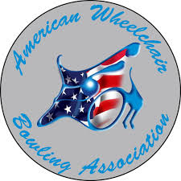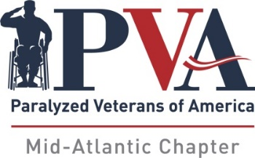

7th ANNUAL PVA MID-ATLANTIC INVITATIONAL
(Sanctioned by AWBA)
Bowl America – Short Pump, VA
September 22-24, 2023

REGISTRATION DEADLINE - SEPTEMBER 1, 2023

On behalf of the PVA Mid-Atlantic Chapter, please accept our invitation to join us for the 7th Annual PVA Mid-Atlantic Invitational – Sanctioned by AWBA. Every year, our tournament committee takes great pride in providing our bowlers, their families and caregivers with a first-class experience – and this year we hope to showcase our best event yet!

To assist with your individual reservations, we are listing some hotels close to the bowling center – all of which have many restaurants and popular shopping areas nearby. Please be aware that the tournament committee will not be handling transportation to or from the hotels or bowling center. It will be helpful if those of you who are driving would consider ride sharing with your fellow participants.

As tournament director, I hope that each of you will consider joining us this year. Even better, spread the word, and share the fun and excitement of our tournament with other bowlers!

Yours in fellowship,

Jimmy May
Tournament Director
PVA Mid-Atlantic Chapter
11620 Busy St
No. Chesterfield, VA 23236
804-378-0017

Jimmy May
2641 Sandhurst Ln
Midlothian VA, 23113
Home 804-794-7447
Cell 804-240-9019

Bowl America - Short Pump
4400 Pouncey Tract Rd
Glen Allen, VA 23060
804-360-8222

Hampton Inn & Suites
12341 W. Broad St
Richmond, VA 23233
804-773-7111

Fairfield Inn & Suites
9937 Mayland Drive
Richmond, VA 23223
804-799-1200
Holiday Inn Express I-64
9933 Mayland Drive
Richmond, VA 23233
844-684-9427
Hyatt Place Innsbrook
4100 Cox Rd
Glen Allen, VA
804-794-9644
Hilton Garden
4050 Cox Rd
Glen Allen, VA 23060
804-521-2900

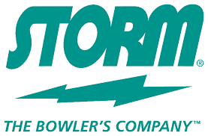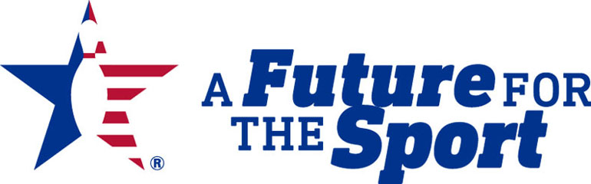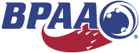

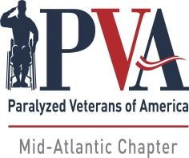
7th ANNUAL PVA MID-ATLANTIC INVITATIONAL
(Sanctioned by AWBA)
September 22-24, 2023

BOWLING CENTER LOCATION:
AWBA#: USBC#:
Bowl America - Short Pump
4400 Pouncey Tract Rd
Glen Allen, VA 23060

ALL REGISTRATIONS & PAYMENTS MADE DIRECTLY TO PVA MID-ATLANTIC

Singles Entry Fee: $140.00
Doubles: $ 30.00
Up & Down: $ 30.00

7th Year Donation: $

Total: $

Mail Entry & Fees To:
PVA Mid-Atlantic
11620 Busy St.
No. Chesterfield, VA 23236
Or: via PayPal: https://www.pvamidatlantic.org/donate/

Please Print:
Name:
Address:
City: State: Zip:
Phone#: Email:

Check Division Entering: SCRATCH: HANDICAP:

Doubles: Partner: Handicap: Please Assign:

Up & Down: Partner: Handicap: Please Assign:
Partner: Handicap: Please Assign:
Partner: Handicap: Please Assign:

Average Verification: Failure to provide required verification will result in any prize money and/or other awards
being withheld until such verification is submitted.

Those without qualified averages must bowl in the scratch division. The AWBA adjusted tournament average designee will provide adjusted tournament average information. In all cases where the adjusted tournament average is USBC book average, the adjusted tournament average will be the entrant's entering average. All participants must present valid AWBA and USBC membership cards. AWBA and USBC membership fees will be accepted for new members, which is required to participate in the event. For new bowlers, a league scoresheet will be accepted to establish an average (a minimum of 12 games).

Signature

Please check all that apply Power Chair ___ Manual _ Para _ Quad ___ Stick __
Are You a PVA Member? ____Yes ____No Chapter:_____________________
Shirt Size: M L XL 2XL 3XL

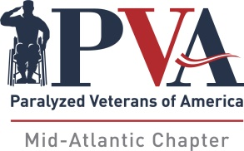
7th ANNUAL PVA MID-ATLANTIC INVITATIONAL
(Sanctioned by AWBA)

SINGLES PRIZE FUND

Scratch Division A Division B Division
1st $1250 1st $1250 1st $1250
2nd 900 2nd 900 2nd 900
3rd 600 3rd 600 3rd 600
4th 400 4th 400 4th 400
5th 300 5th 300 5th 300
Total $3450 6th 150 6th 150
Total $3600 Total $3600

Scratch Division Scratch Division A & B Divisions A & B Divisions TOTAL
HSG - $75 HHS - $75 HHG - $75 x 2 HHS - $75 x 2 $ 450

DOUBLES PRIZE FUND

1st $450
2nd $250
3rd $150
Total $850

UP & DOWN PRIZE FUND

1st $450
2nd $300
3rd $225
Total $975

TOTAL TOURNAMENT PRIZE FUND - $12,925

The PVA Mid-Atlantic Chapter reserves the right to increase or decrease the prize fund

based on overall registrations and participants
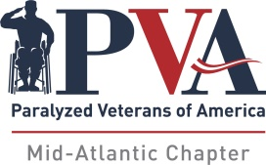

7th Annual PVA Mid-Atlantic Invitational
(Sanctioned by AWBA)
Bowl America - Short Pump
September 22-24, 2023

Tentative Schedule of Events
Friday – September 22nd
Donuts & Coffee 9:00 AM
Team Check-In 9:30 AM
Doubles__________________________ 10:30 AM
Clinic for Novice Bowlers____________ 1:30 PM
Up & Down Check-In 6:00 PM
Up & Down Bowling 7:00 PM

Donuts & Coffee 9:00 AM
Check-In 9:30 AM
Third Qualifying Squad - 3 Games 10:00 AM
Lunch (Provided) 12:00 PM
Fourth Qualifying Squad - 3 Games 1:00 PM
Roll-off - Scratch, "A" & "B" divisions 3:30 PM
Awards will follow Roll-off
Sunday – September 24th
Donuts & Coffee 9:00 AM
Singles Check-In 10:00 AM
Opening Ceremonies 10:30 AM
First Qualifying Squad 10:45 AM
Lunch (Provided) 12:30 PM
Second Qualifying Squad 1:45 PM

Saturday - September 23rd

