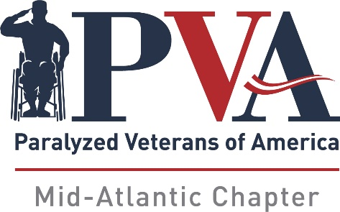

-PVA Mid-Atlantic Chapter Scholarship Program-

MISSION: The mission of the PVA Mid-Atlantic Chapter Scholarship Program is to provide financial assistance to qualified individuals pursuing an undergraduate or graduate degree, or attaining certification through an accredited trade school. The PVA Mid-Atlantic Chapter will grant up to five (5) scholarships of $1,000 each for selected applicants who fulfill each of the established guidelines and criteria.

GUIDELINES:
- PVA Mid-Atlantic Scholarships are available for qualified applicants who are students entering or enrolled in an accredited college, university, community college or trade school. Full-time and part-time students will be considered.
- Applicants must be a PVA Mid-Atlantic Chapter member or associate member, or the spouse, child or grandchild of a PVA Mid-Atlantic Chapter member or associate member.
- The deadline for applications to be received in the PVA Mid-Atlantic Chapter office is June 1, 2023 at 5 PM. - No Exceptions.
- All supporting documents, including the most recent official academic transcript (high school or post-secondary) must be included in the application. Incomplete applications will not be considered.
- All information is to be typed or printed legibly.
- The Scholarship Committee retains the option of scheduling a virtual, personal interview with any applicant.
- Scholarship recipients will be notified by July 1, 2023.
CRITERIA: The scholarships will be awarded based on the following criteria:
- Academic performance and awards (if any)
- Leadership initiative
- School and/or community activity involvement
- Employment or Volunteer participation
- Clear expression of aspirations and goals presented in essay form.
- One letter of recommendation from an individual not related to the applicant.

SCHOLARSHIP AWARD: Scholarship recipients will be recognized at the PVA Mid-Atlantic Chapter Board of Directors meeting on July 12, 2023.

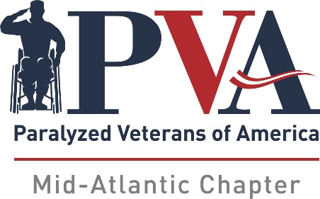
PVA Mid-Atlantic Chapter Scholarship Application

Last Name _________________________ First Name ________________________ MI_____
Address __________________________ City ____________________ State ____ Zip ______
Home Phone _______________ Cell Phone ________________ E-mail___________________
Degree: Undergraduate ___ Graduate ___Trade School___ Full-time ___ Part-Time ___
Name of Chapter Member _________________________ Relationship to Member___________
High School Information:
Name ________________________________________________________________________
Address ______________________________________________________________________
Phone Number ________________________________________________________________
Principal or Guidance Counselor__________________________________________________
Year of Graduation _________ GPA ________ Class Rank ______ Out of _______
Letter of Recommendation (May not be a relative)
Name _______________________ Phone __________________ Email ___________________
School or community organizations in which you have been an active member (Most recent)
School or Organization | Position | Active Dates
List any employment or volunteer positions (Most recent)
Company | Job Title | Active Dates | Contact Phone

List any earned academic achievements, awards and honors (additional sheet, if necessary):
________________________________________________
________________________________________________
________________________________________________

REQUIRED ESSAY:
On a separate sheet, please describe in detail your career aspirations, the importance of earning your degree or professional certification, and how this scholarship will assist you in attaining your goals. (200 words or less):

Please mail your completed applications, along with your academic transcript and essay to:

Scholarship Committee
PVA Mid-Atlantic Chapter
11620 Busy Street
No. Chesterfield, VA 23236

Deadline for receipt of submissions is June 1, 2023 at 5:00 P.M.

Applicants will receive e-mail confirmation when their application has been received.

If you have any questions regarding the application and selection process, you can e-mail our Mid-Atlantic Chapter Headquarters: vapva@aol.com

