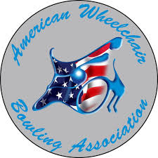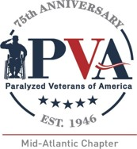
6th Annual PVA Mid-Atlantic/AWBA Invitational
Up/Down Tournament
Bowl America
4400 Pouncey Tract Rd
Glen Allen, VA 23060
September 9th, 2022 at 6pm

PVA Mid-Atlantic is excited to host our 6th Annual Up/Down Bowling Event. Please join us for this FUN evening of bowling, which will pair one of our veterans with a stand-up bowler for the chance to win cash prizes and more. It will be a night full of fun competition and laughs! Food and drink will be available to you. Check in begins at 6pm and bowling will start at 7pm. The entry fee is $25 and can be sent through https://www.pvamidatlantic.org/donate/ or mailed to:

PVA Mid-Atlantic
11620 Busy Street
North Chesterfield, VA 23236

Name Phone Number
Address City, State
Email Company

