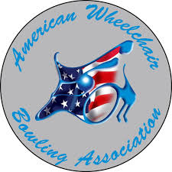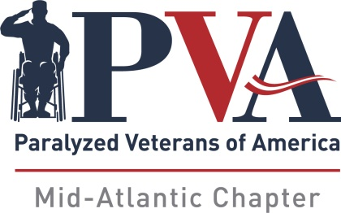

6th Annual Mid-Atlantic PVA / AWBA Invitational
Bowl America - Short Pump, VA
September 9-11, 2022

On behalf of the PVA Mid-Atlantic Chapter, we extend this invitation to attend our tournament. The tournament committee has worked extremely hard to make this weekend enjoyable for each of you. We are honored to host the 6th annual PVA Mid-Atlantic/AWBA Invitational to be held in Richmond, Virginia, September 9-11. Hopefully you will be among the entrants for the events this year at Bowl America – Short Pump.

The tournament committee is not handling transportation to the hotel or bowling center. It will be helpful if those of you who are driving would consider ride sharing with your fellow participants. Most hotel chains offer accommodations in the vicinity and we recommend that you check their individual websites for specifics. Please make reservations at your earliest convenience, using the motel information that is included below.
As tournament director, I hope that each of you will consider joining us this year. Even better, bring a bowling friend along with you.

Yours in fellowship,
Jimmy May, Tournament Director

Jimmy May
2641 Sandhurst Ln
Midlothian VA, 23113
Home 804-794-7447
Cell 804-240-9019
Bowl America - Short Pump
Mid-Atlantic PVA
11620 Busy St
Chesterfield, VA 23236
Ivan Schwartz
804-378-0017
4400 Pouncey Tract Rd
Glen Allen, VA 23060
Cheryl Clatterbaugh
804-360-8222

Fairfield Inn & Suites
9937 Mayland Drive
Richmond, VA 23223
804-799-1200
Holiday Inn Express I-64
9933 Mayland Drive
Richmond, VA 23233
844-684-9427
Hyatt Place Innsbrook
4100 Cox Rd
Glen Allen, VA
804-794-9644
Wingate
13991 N. Gayton Rd
Richmond, VA 23233
804-421-1600

Hilton Garden
4050 Cox Rd
Glen Allen, VA 23060
804-521-2900

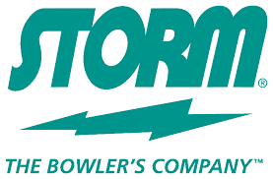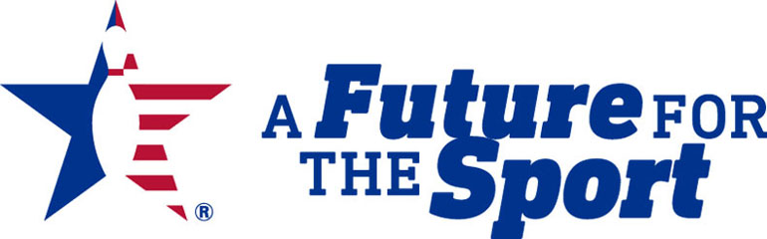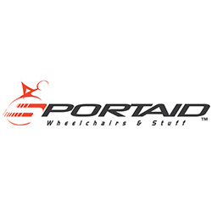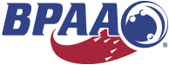
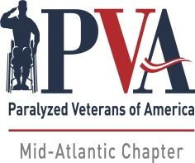
6th Annual PVA Mid-Atlantic / AWBA Invitational
September 9-11, 2022

Games Bowled At:
AWBA#: USBC#:
Bowlero Short Pump
4400 Pouncey Tract Rd
Glen Allen, VA 23060
Singles Entry Fee: $135.00
Doubles: $30.00
Up & Down: $25.00

5th Year Donation: $

Total: $

Mail Entry & Fees To:
PVA Mid-Atlantic
11620 Busy St.
North Chesterfield, VA 23236
Or PayPal at https://www.pvamidatlantic.org/donate/

Please Print:
Name:
Address:
City: State: Zip:
Phone#: Email:

Check Division Entering: SCRATCH: HANDICAP:
Doubles: Partner: Handicap: Please Assign:
Up & Down: Partner: Handicap: Please Assign:
Partner: Handicap: Please Assign:
Partner: Handicap: Please Assign:

Average Verification: Failure to provide required verification will result in any prize money and/or other awards being withheld until such verification is submitted.

Entrants without qualified averages must bowl scratch. The AWBA adjusted tournament average designee will provide adjusted tournament average information. In all cases where the adjusted tournament average is USBC book average, the adjusted tournament average will be the entrant's entering average. AWBA and USBC member cards must be presented. For new bowlers, a league sheet will be accepted as long as 12 games have been bowled establishing the average.

Entrants Signature
Please check all that apply Power Chair Manual Para Quad Stick
Are You A Member of PVA? Which Chapter?
Shirt Size: M L XL XXL XXXL

Confirmation of your entry will be returned via email with your entering average.
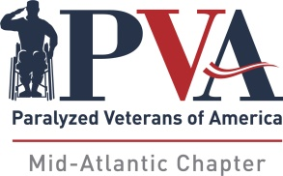
6th Annual PVA Mid-Atlantic/AWBA Invitational
SINGLES PRIZE FUND

SCRATCH DIVI (5)
1st $1,200.00
2nd $800.00
3rd $550.00
4th $350.00 5th $250.00
Total - $3,150
A-DIVI (8)
1st $1,200.00
2nd $800.00
3rd $550.00
4th $350.00 5th $250.00 6th $100.00
Total - $3,250
B-DIVI (10)
1st $1,200.00
2nd $800.00
3rd $550.00
4th $350.00 5th $250.00 6th $100.00
Total - $3,250
A & B A & B Scratch Scratch Total: HHG $75.00 x2 HHS $75.00 x 2 HSG $75.00 HSS$75.00 $450.00
DOUBLES PRIZE FUND
1st $450.00
2nd $250.00
3rd $150.00
Total Doubles Prize Fund --------------------------------------------------------------$850.00
UP&DOWN PRIZE FUND

1st $450.00
2nd $300.00
3rd $225.00
Total Up & Down Prize Fund-----------------------------------------------------------------$975.00

TOTAL PRIZE FUND $11,925.00

The PVA Mid-Atlantic Chapter reserves the right to increase or decrease the prize fund

based on overall registrations and participants

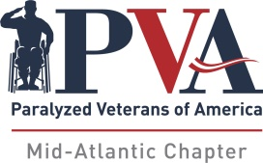

6th Annual PVA Mid-Atlantic/AWBA Invitational
Bowl America Short Pump
September 9-11, 2022

Tentative Schedule of Events
Friday - September 9th
Donuts & Coffee 9:00 AM
Team Check-in 9:30 AM
Doubles 10:30 AM
New Bowler Clinic (Bowl 3 Games) 1:30 PM
Up & Down Check-in 6:00 PM
Up & Down Bowling 7:00 PM

Donuts & Coffee 9:00 AM
Check-in 9:30 AM
Third Qualifying Squad - 3 Games 10:00 AM
Lunch (Free) 12:00 PM
Fourth Qualifying Squad - 3 Games 1:00 PM
Roll-off - Scratch, "A" & "B" divisions 3:30 PM
Awards will follow Roll-off
Sunday - September 11th
Donuts & Coffee 9:00 AM
Singles Check-in 10:00 AM
Opening Ceremonies 10:30 AM
First Qualifying Squad 10:45 AM
Lunch (Free) 12:30 PM
Second Qualifying Squad 1:45 PM

Saturday - September 10th

